Week V

API

An API lets two pieces of software talk to each other. Just like a function, you don't have to know how the API works, only its inputs and outputs. An essential type of API is a REST API that allows you to access resources via the internet. In this lab, we will review the Pandas Library in the context of an API, we will also review a basic REST API.

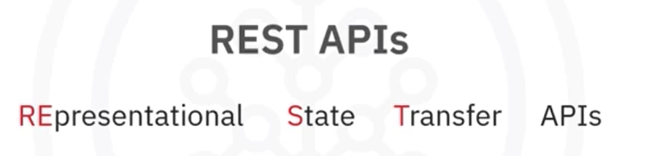 

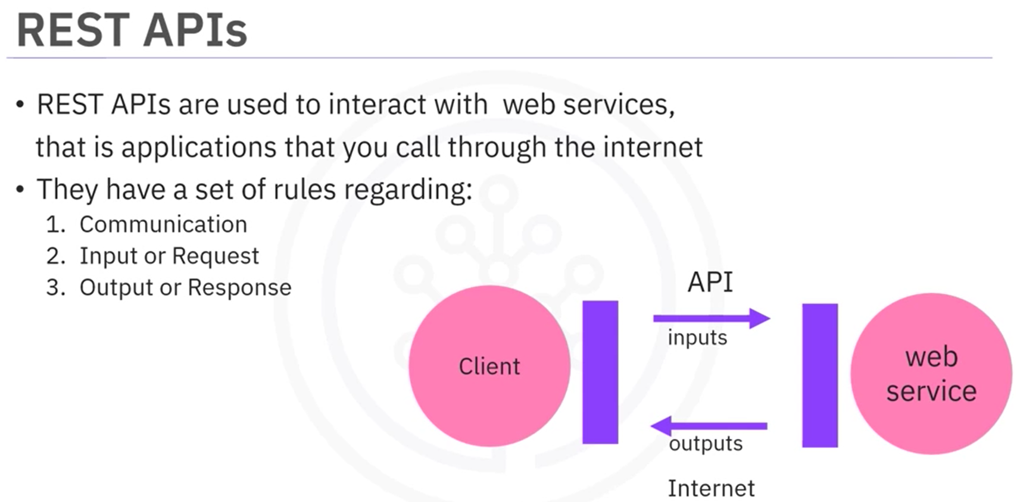

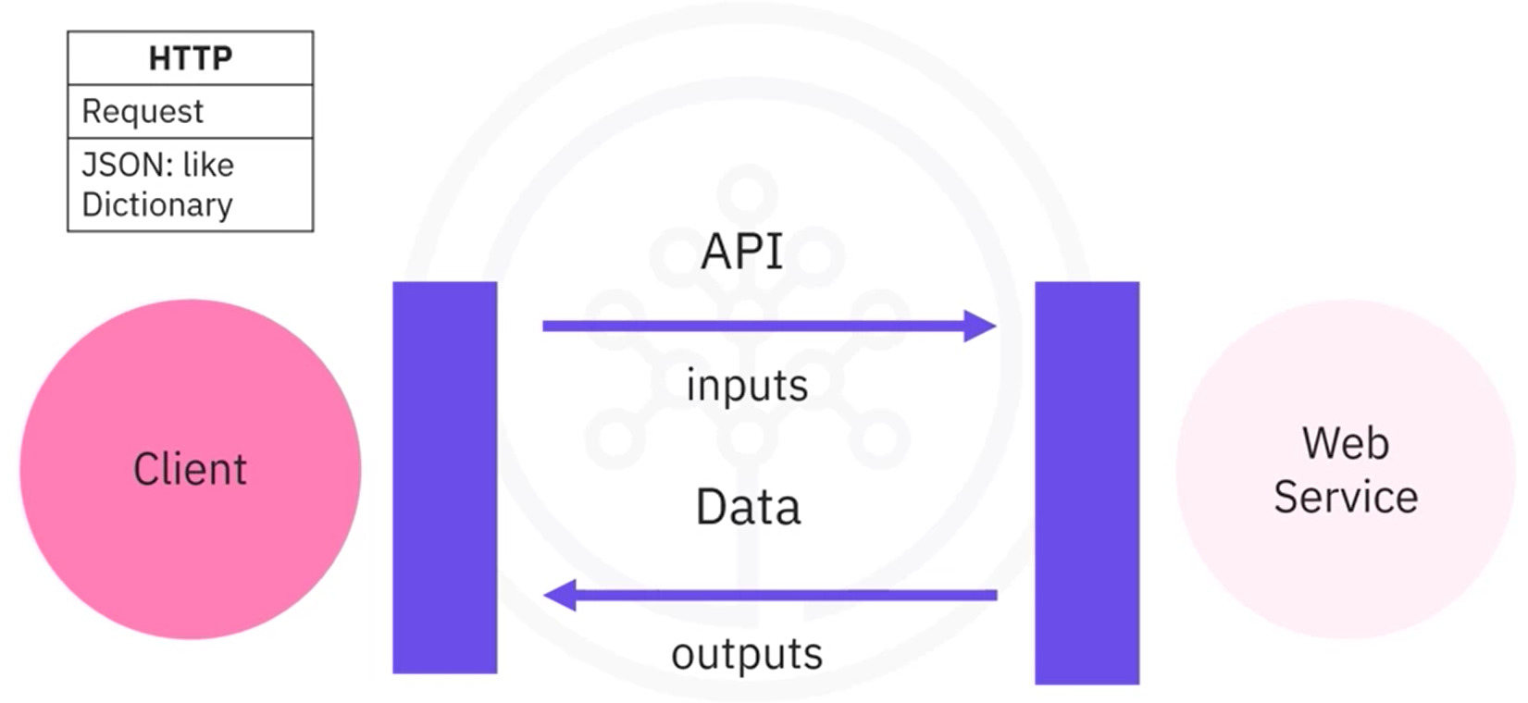

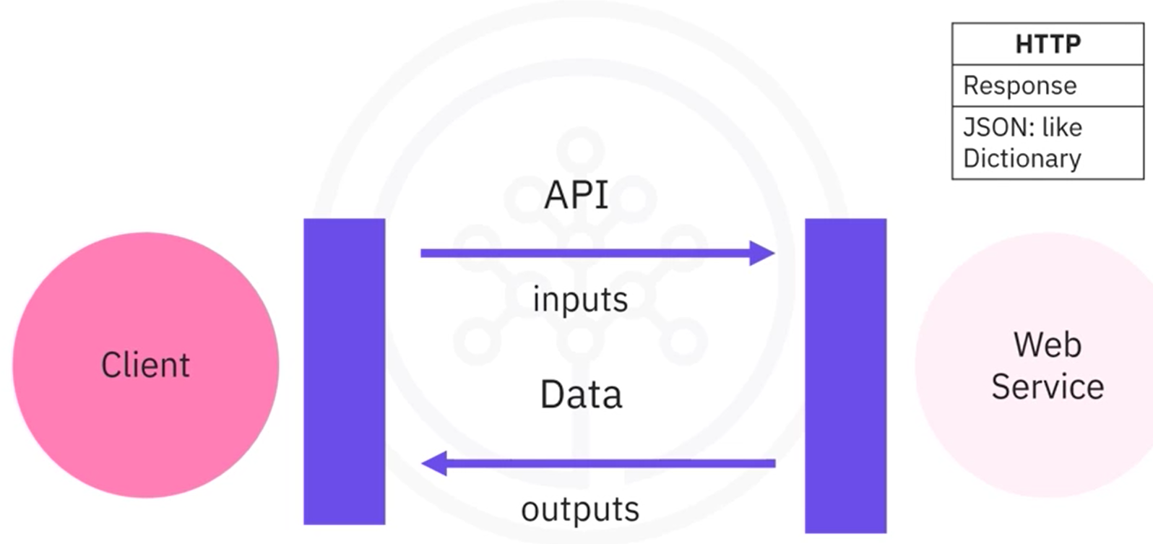

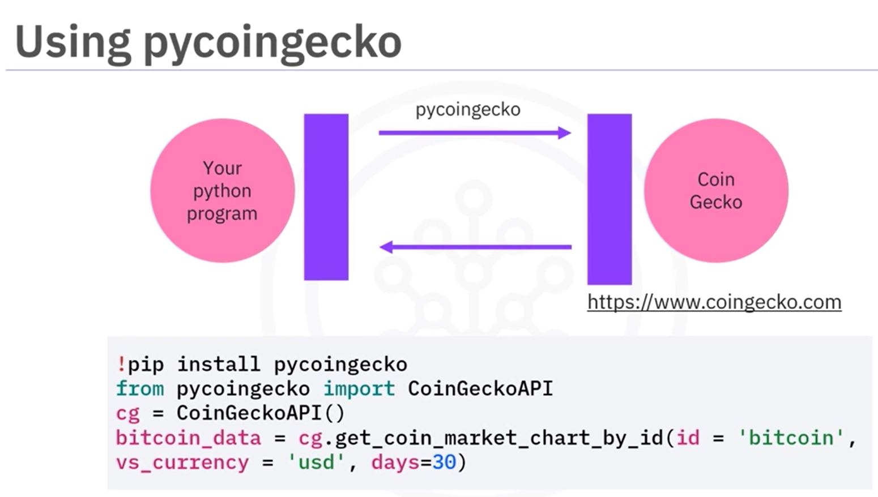

import numpy as np

import pandas as pd

# You can also use this section to suppress warnings generated by your code:

def warn(*args, **kwargs):

pass

import warnings

warnings.warn = warn

warnings.filterwarnings('ignore')

URL=<https://web.archive.org/web/20230902185326/https://en.wikipedia.org/wiki/List_of_countries_by_GDP_%28nominal%29>

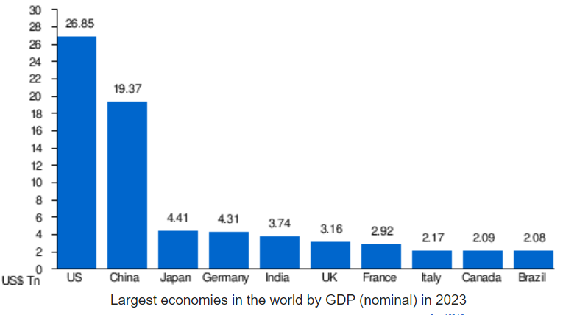 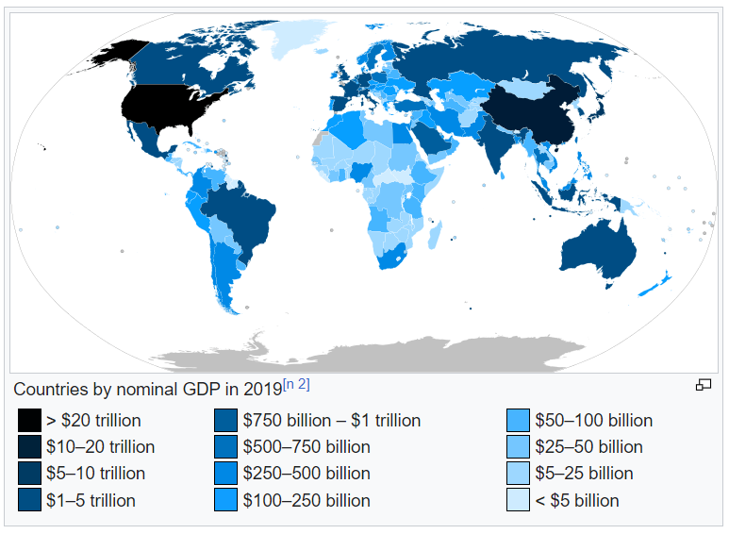

# Extract tables from webpage using Pandas. Retain table number 3 as the required dataframe.

tables = pd.read_html(URL)

df = tables[3]

# Replace the column headers with column numbers

df.columns = range(df.shape[1])

# Retain columns with index 0 and 2 (name of country and value of GDP quoted by IMF)

df = df[[0,2]]

# Retain the Rows with index 1 to 10, indicating the top 10 economies of the world.

df = df.iloc[1:11,:]

# Assign column names as "Country" and "GDP (Million USD)"

df.columns = ['Country','GDP (Million USD)']

# Change the data type of the 'GDP (Million USD)' column to integer. Use astype() method.

df['GDP (Million USD)'] = df['GDP (Million USD)'].astype(int)

# Convert the GDP value in Million USD to Billion USD

df[['GDP (Million USD)']] = df[['GDP (Million USD)']]/1000

# Use numpy.round() method to round the value to 2 decimal places.

df[['GDP (Million USD)']] = np.round(df[['GDP (Million USD)']], 2)

# Rename the column header from 'GDP (Million USD)' to 'GDP (Billion USD)'

df.rename(columns = {'GDP (Million USD)' : 'GDP (Billion USD)'})

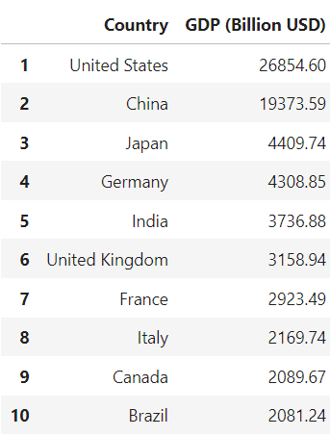 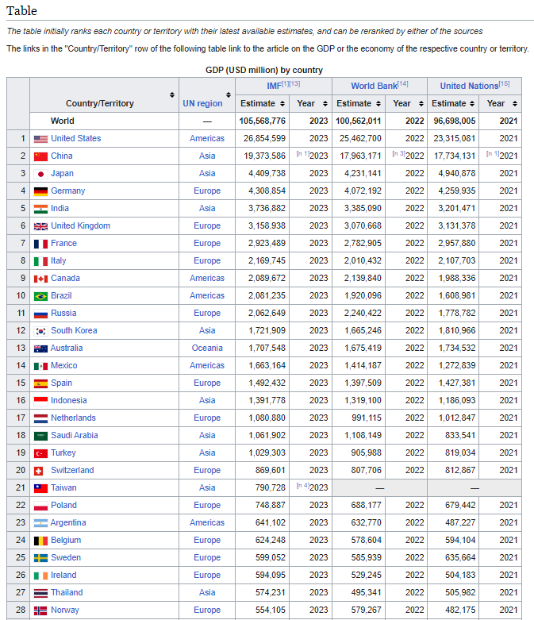

# Load the DataFrame to the CSV file named "Largest_economies.csv"

df.to_csv('./Largest_economies.csv')

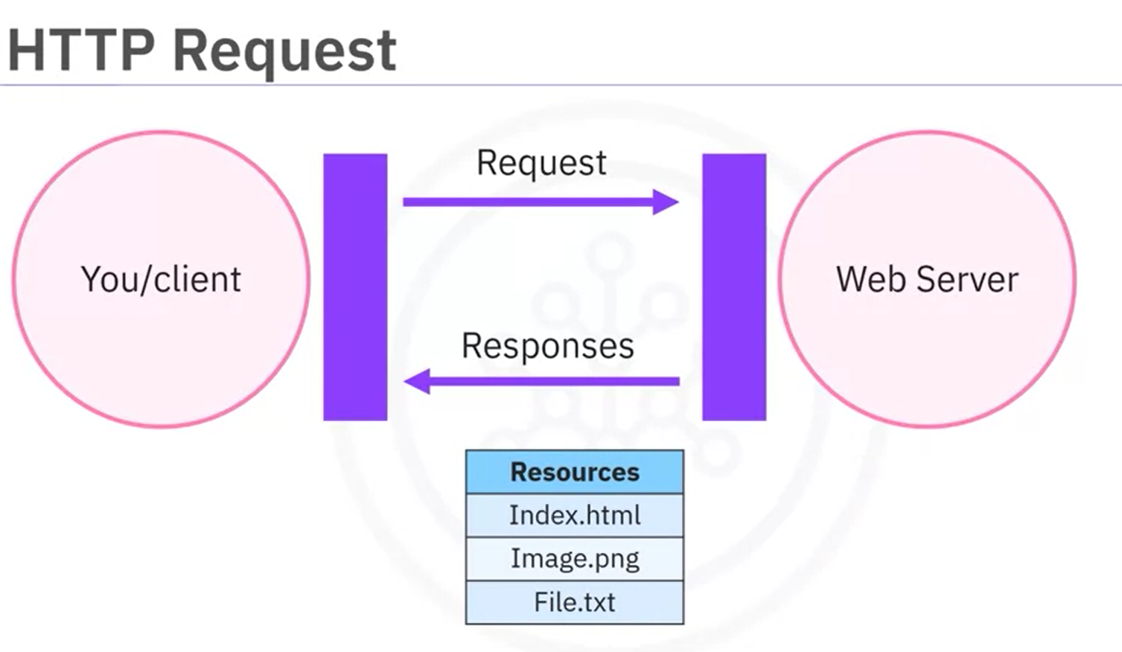

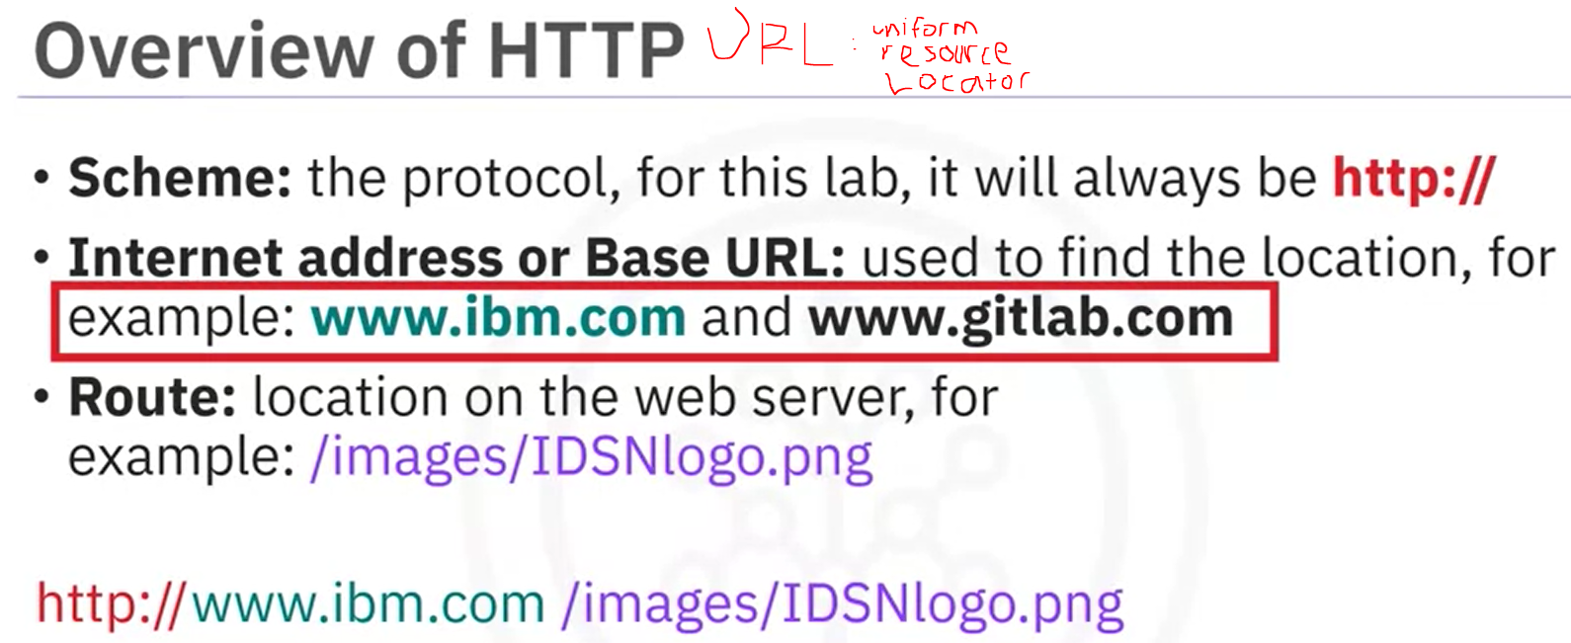

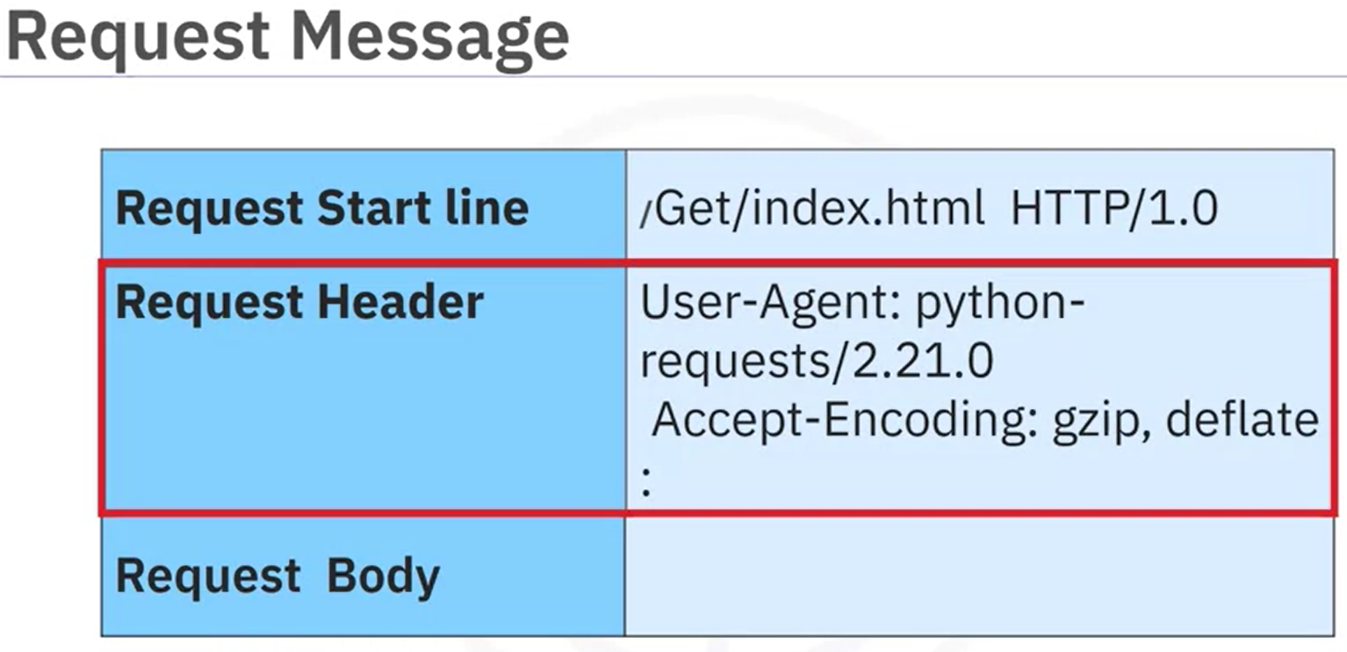

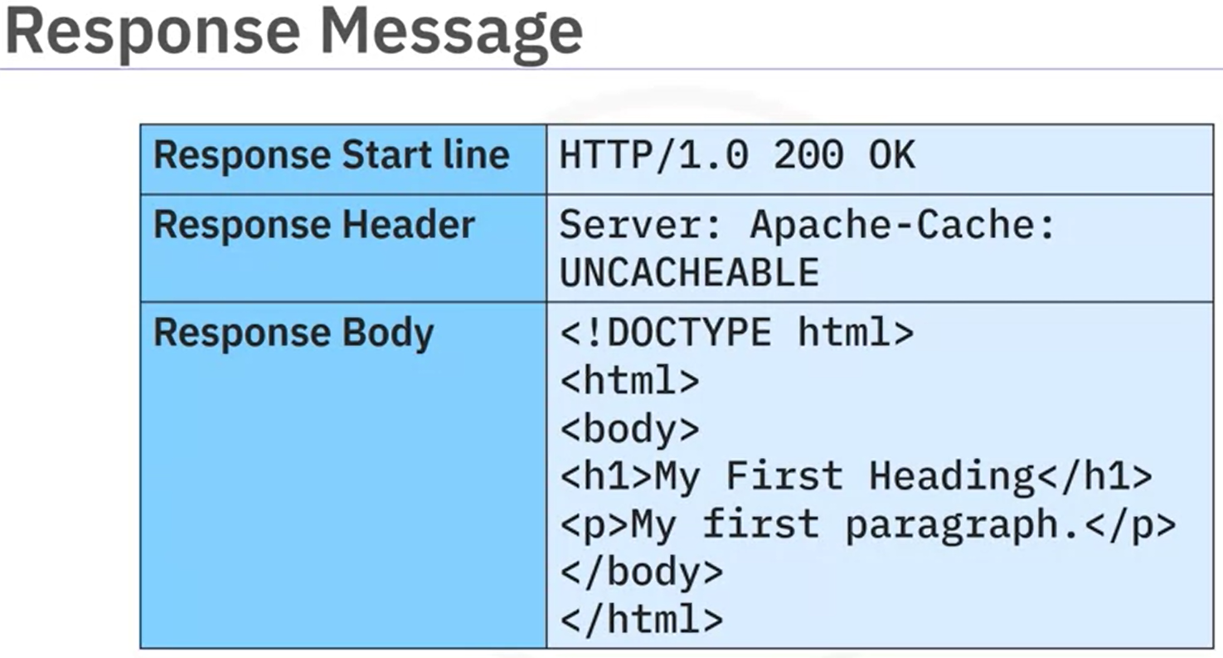

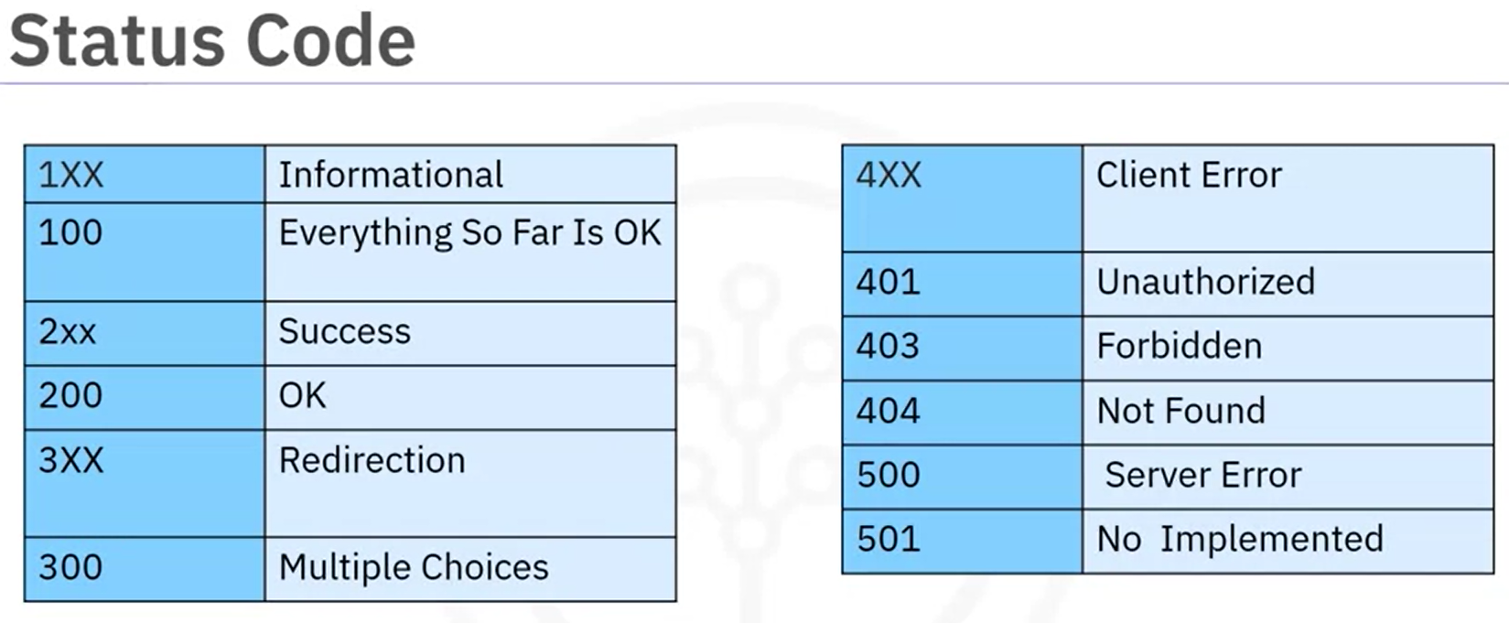

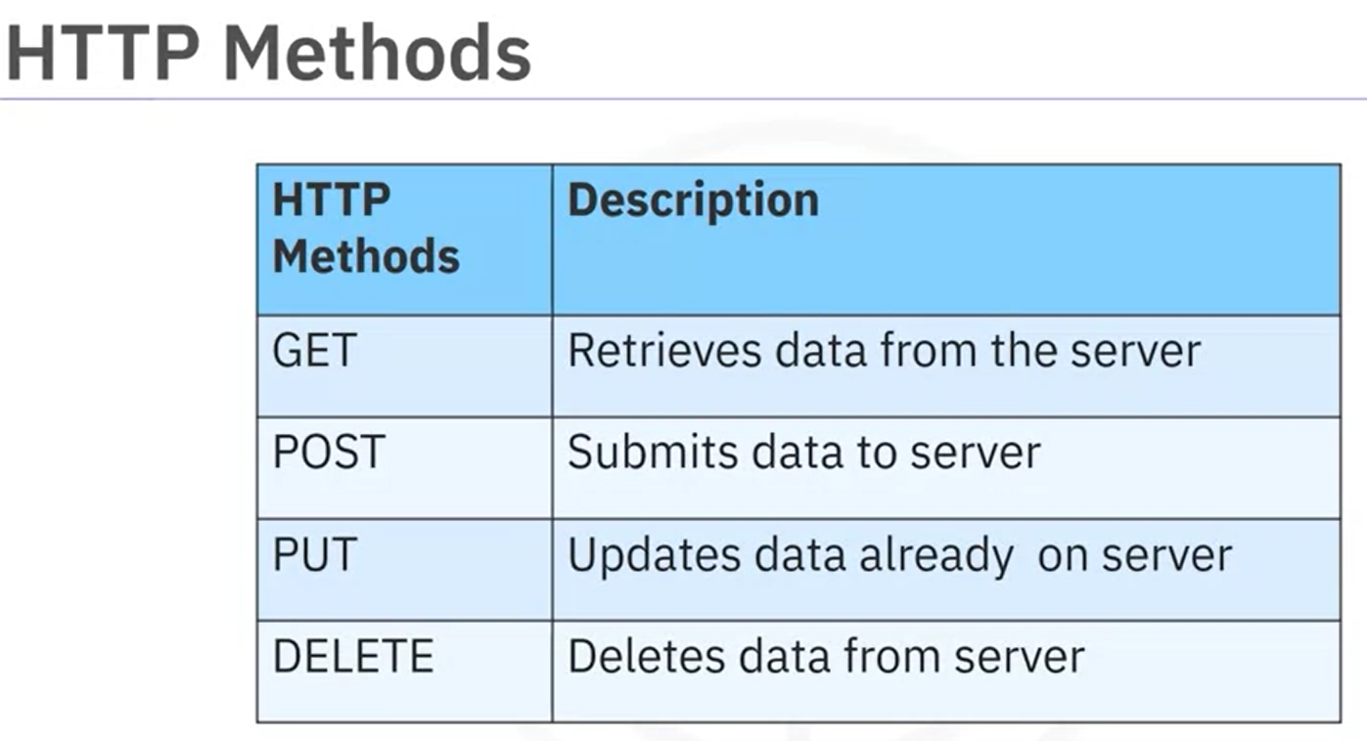

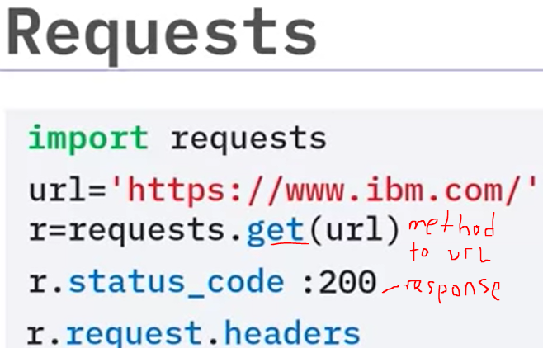 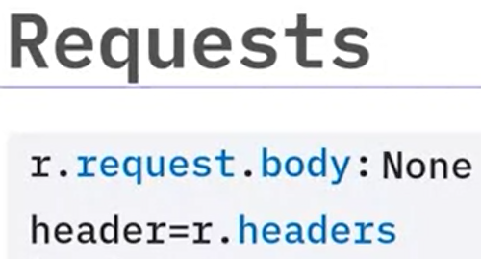

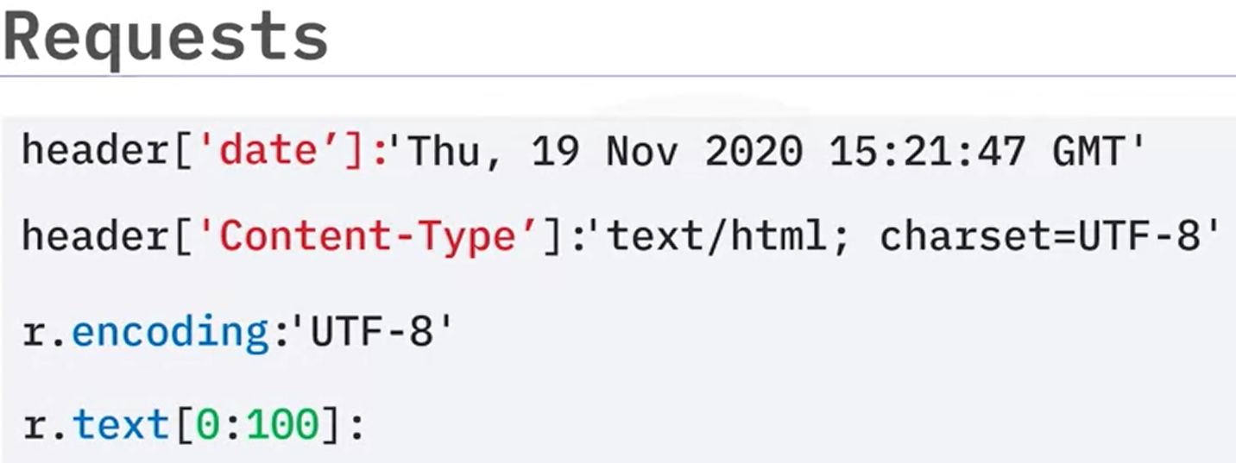

GET REQUEST with URL PARAMETERS

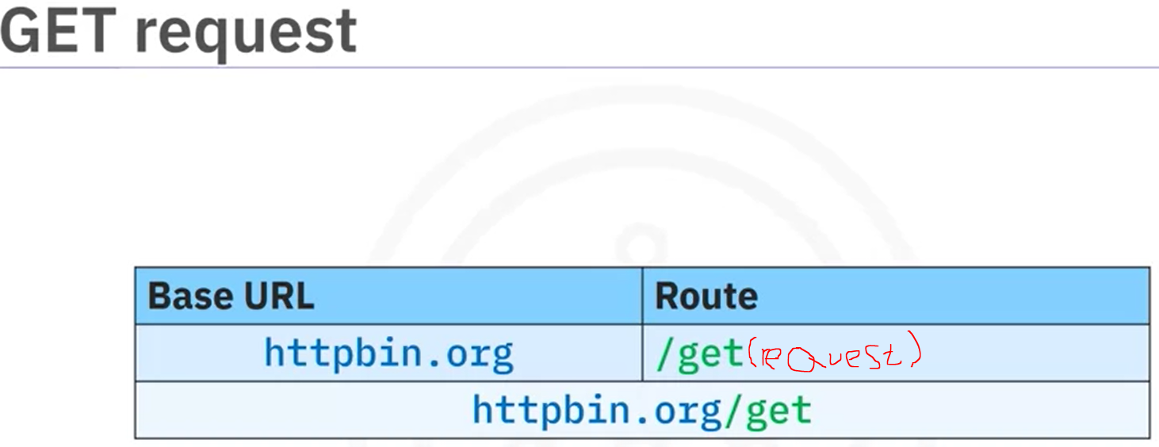

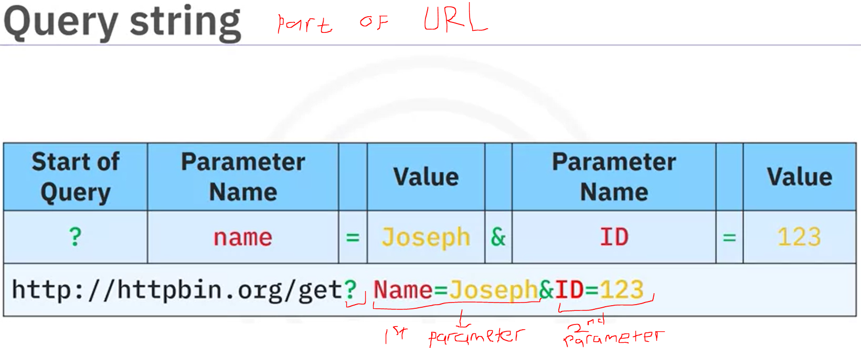

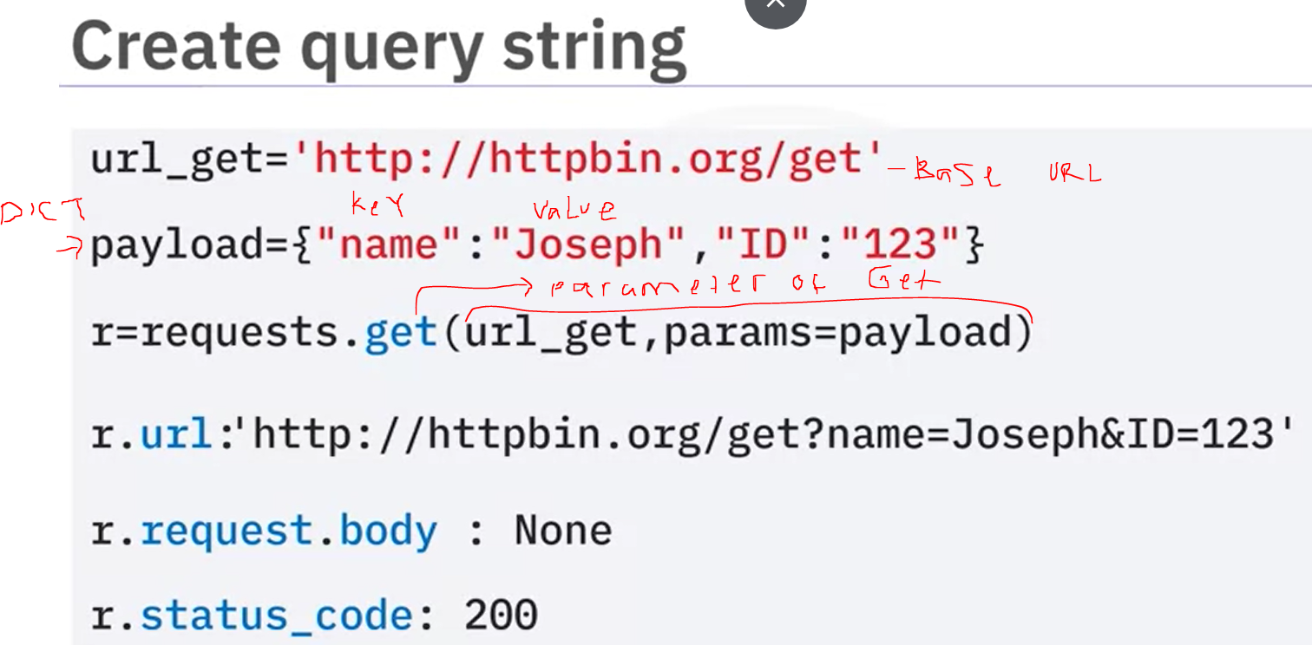

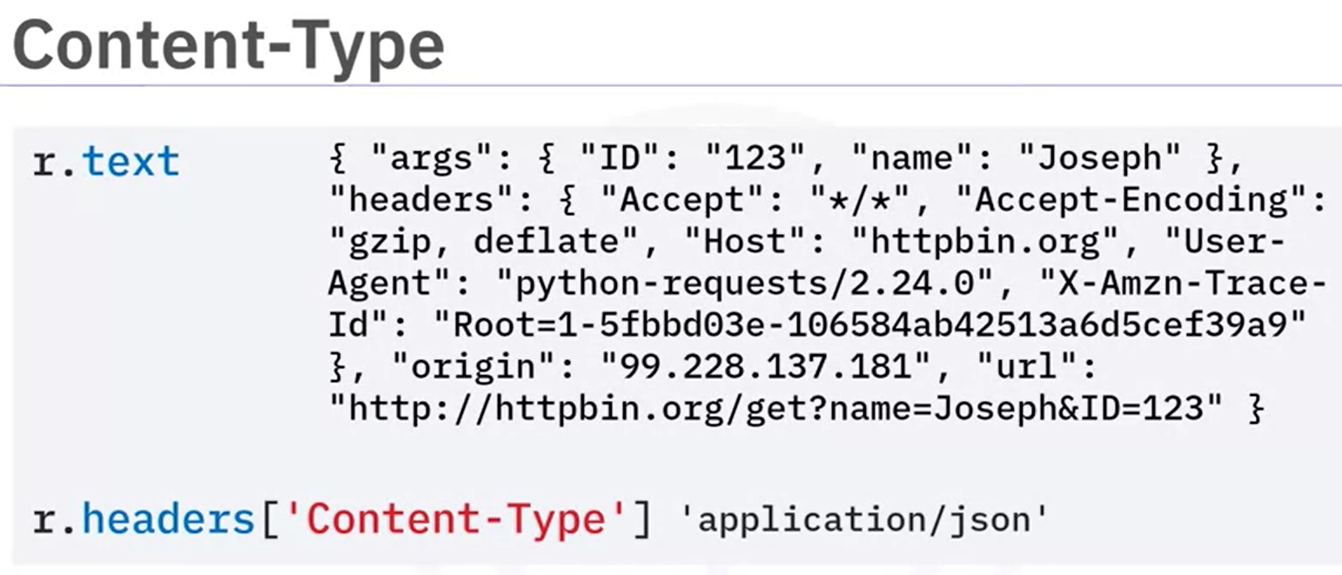 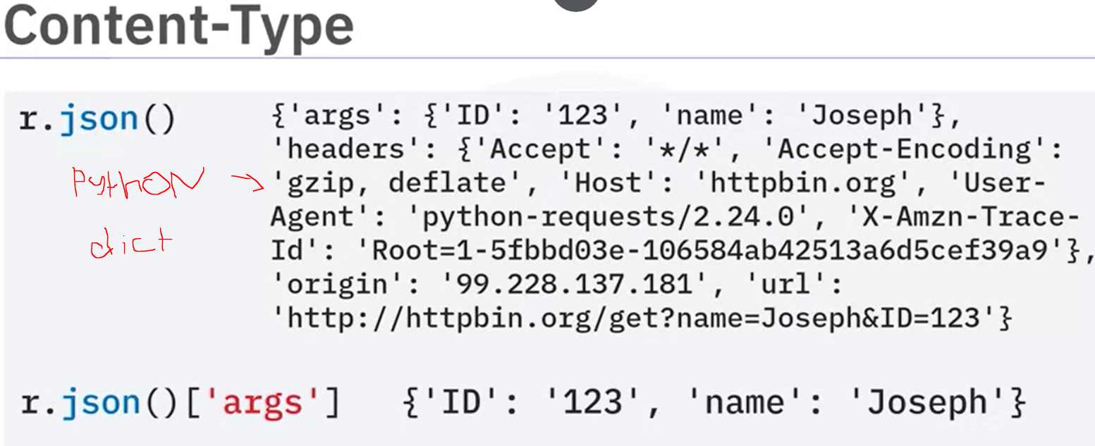

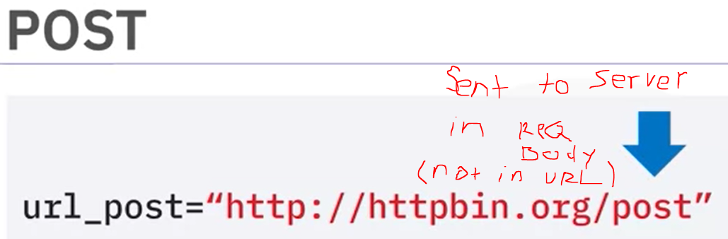

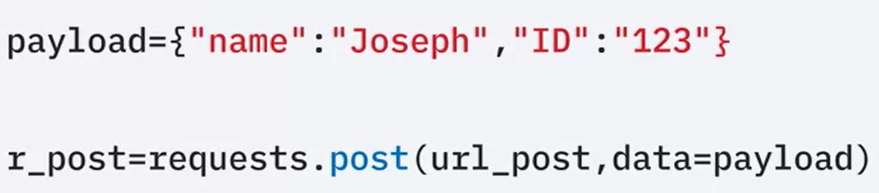

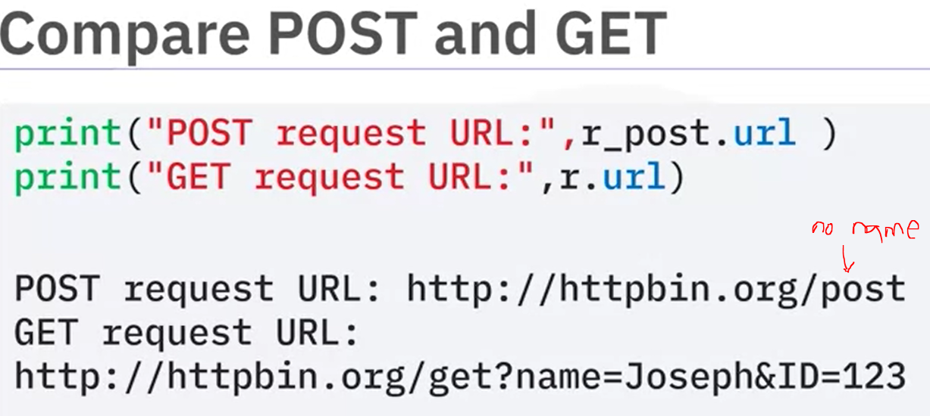

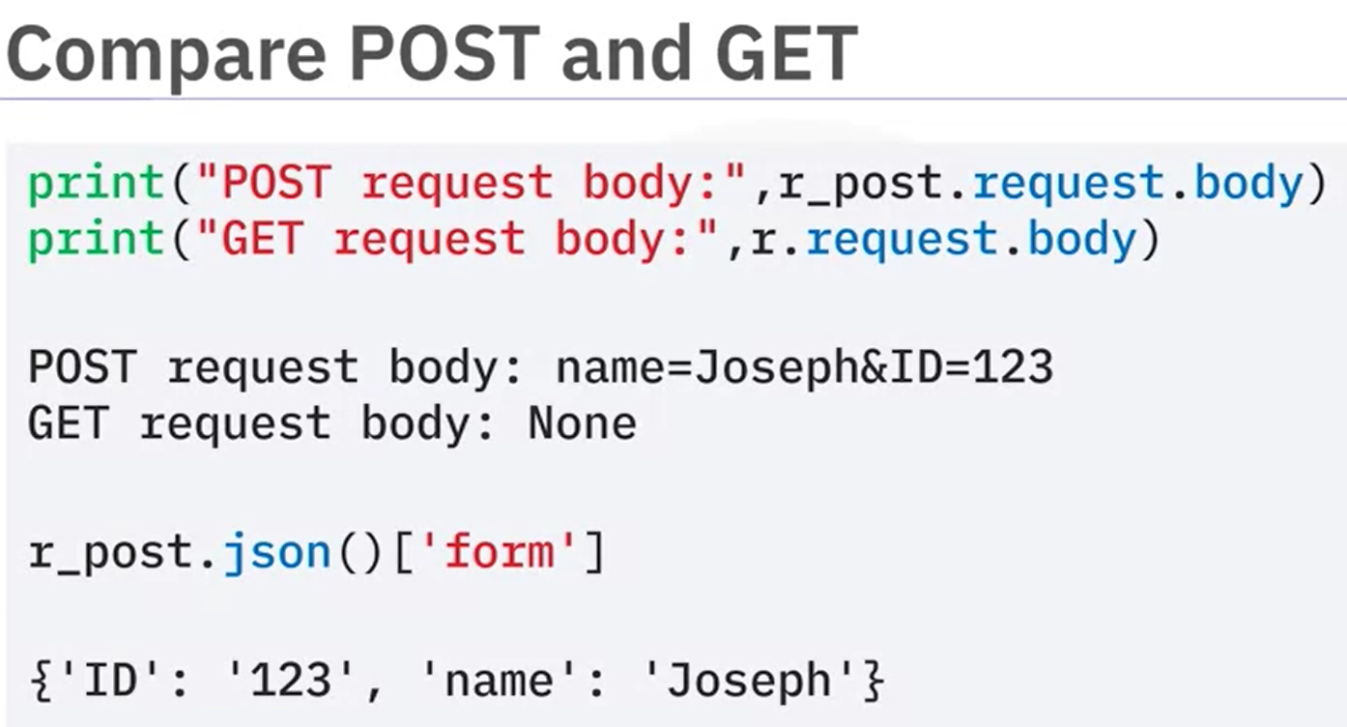

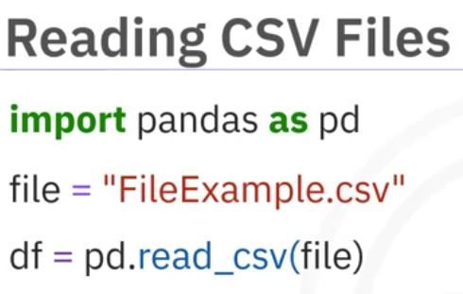

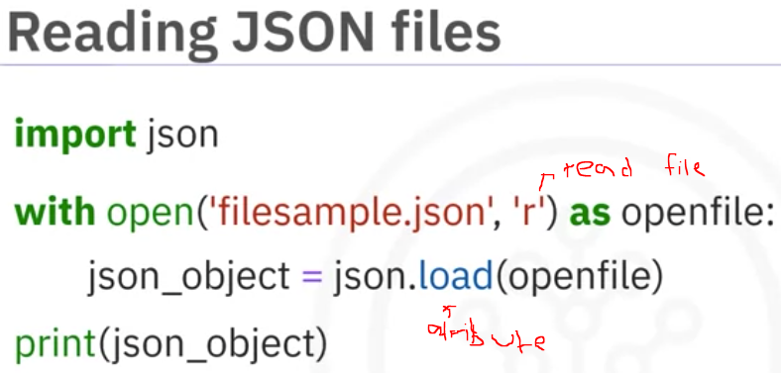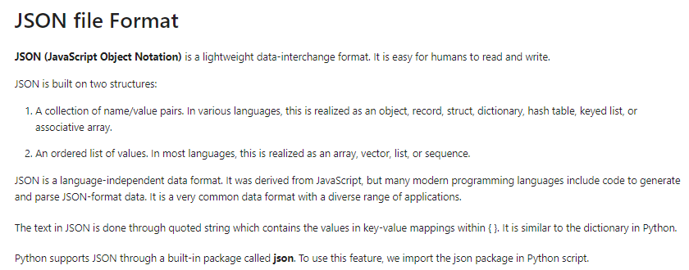

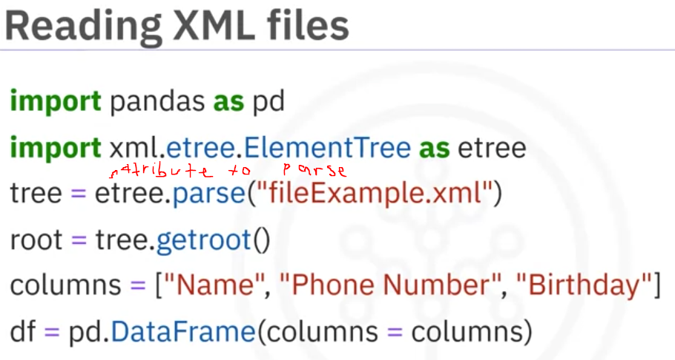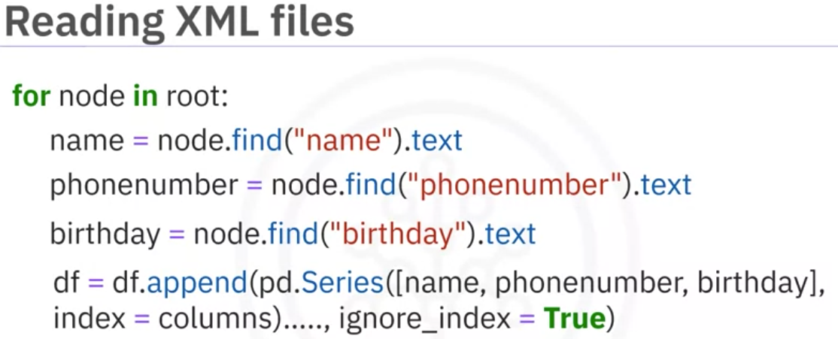

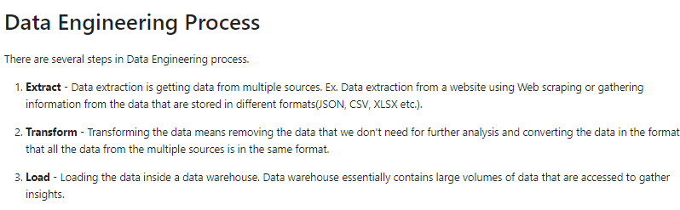

Indexing & Selecting Data :

<https://pandas.pydata.org/pandas-docs/stable/user_guide/indexing.html?utm_medium=Exinfluencer&utm_source=Exinfluencer&utm_content=000026UJ&utm_term=10006555&utm_id=NA-SkillsNetwork-Channel-SkillsNetworkCoursesIBMDeveloperSkillsNetworkPY0101ENSkillsNetwork19487395-2021-01-01>

DataFrame.transform

<https://pandas.pydata.org/pandas-docs/stable/reference/api/pandas.DataFrame.transform.html?utm_medium=Exinfluencer&utm_source=Exinfluencer&utm_content=000026UJ&utm_term=10006555&utm_id=NA-SkillsNetwork-Channel-SkillsNetworkCoursesIBMDeveloperSkillsNetworkPY0101ENSkillsNetwork19487395-2021-01-01>

